HR_Database - https://cf-courses-data.s3.us.cloud-object-storage.appdomain.cloud/IBMDeveloperSkillsNetwork-DB0201EN-SkillsNetwork/labs/MySQL/week2/HR_Database_Create_Tables_Script.sql

- Department.csv(load data)- https://cf-courses-data.s3.us.cloud-object-storage.appdomain.cloud/IBMDeveloperSkillsNetwork-DB0201EN-SkillsNetwork/labs/Labs_Coursera_V5/datasets/HR_Database/Departments.csv
- Employees.csv (load data)- https://cf-courses-data.s3.us.cloud-object-storage.appdomain.cloud/IBMDeveloperSkillsNetwork-DB0201EN-SkillsNetwork/labs/MySQL/week2/data/Employees_updated.csv
- Jobs.csv - https://cf-courses-data.s3.us.cloud-object-storage.appdomain.cloud/IBMDeveloperSkillsNetwork-DB0201EN-SkillsNetwork/labs/Labs_Coursera_V5/datasets/HR_Database/Jobs.csv
- Locations.csv - https://cf-courses-data.s3.us.cloud-object-storage.appdomain.cloud/IBMDeveloperSkillsNetwork-DB0201EN-SkillsNetwork/labs/Labs_Coursera_V5/datasets/HR_Database/Locations.csv
- JobsHistory.csv - https://cf-courses-data.s3.us.cloud-object-storage.appdomain.cloud/IBMDeveloperSkillsNetwork-DB0201EN-SkillsNetwork/labs/MySQL/week2/data/JobsHistory.csv

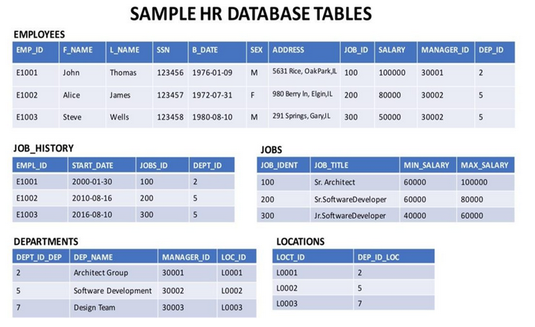
How does a CROSS JOIN (also known as Cartesian Join) statement syntax look?
SELECT column_name(s)
FROM table1
CROSS JOIN table2;

How does an INNER JOIN statement syntax look?
SELECT column_name(s)
FROM table1 INNER JOIN table2
ON table1.column_name = table2.column_name;
WHERE condition;

Example 1:
- Select the names and job start dates of all employees who work for the department number 5.
Hint – Use the Inner join operation with the EMPLOYEES table as the left table and the JOB_HISTORY table as the right table.
Select E.F_NAME,E.L_NAME, JH.START_DATE
from EMPLOYEES as E INNER JOIN JOB_HISTORY as JH
on E.EMP_ID=JH.EMPL_ID
where E.DEP_ID =’5’;
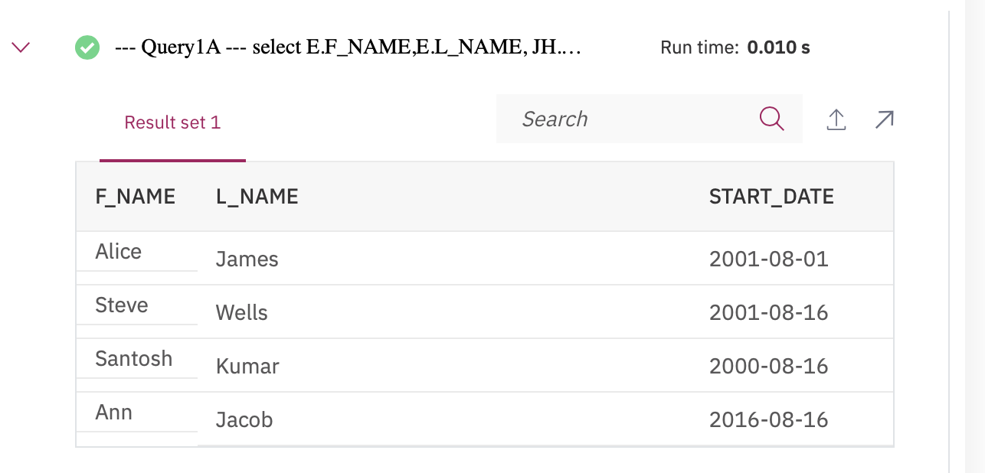

- Select the names, job start dates, and job titles of all employees who work for the department number 5.
Hint - Perform an INNER JOIN with 3 tables ⬜ EMPLOYEES, JOB_HISTORY, JOBS.
select E.F_NAME,E.L_NAME, JH.START_DATE, J.JOB_TITLE
from EMPLOYEES as E
INNER JOIN JOB_HISTORY as JH on E.EMP_ID=JH.EMPL_ID
INNER JOIN JOBS as J on E.JOB_ID=J.JOB_IDENT
where E.DEP_ID ='5';
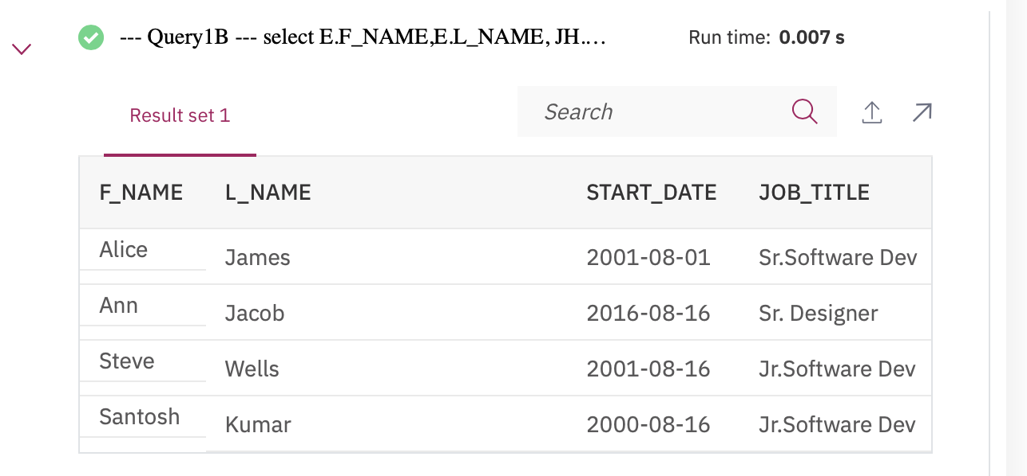

How does a LEFT OUTER JOIN statement syntax look?
SELECT column_name(s)
FROM table1
LEFT OUTER JOIN table2
ON table1.column_name = table2.column_name
WHERE condition;

- Perform a Left Outer Join on the EMPLOYEES and DEPARTMENT tables and select employee id, last name, department id and department name for
all employees.
Hint – Use the Left Outer Join operation with the EMPLOYEES table as the left table and the DEPARTMENTS table as the right table.
Select E.EMP_ID,E.L_NAME,E.DEP_ID,D.DEP_NAME
from EMPLOYEES AS E
LEFT OUTER JOIN DEPARTMENTS AS D ON E.DEP_ID=D.DEPT_ID_DEP;

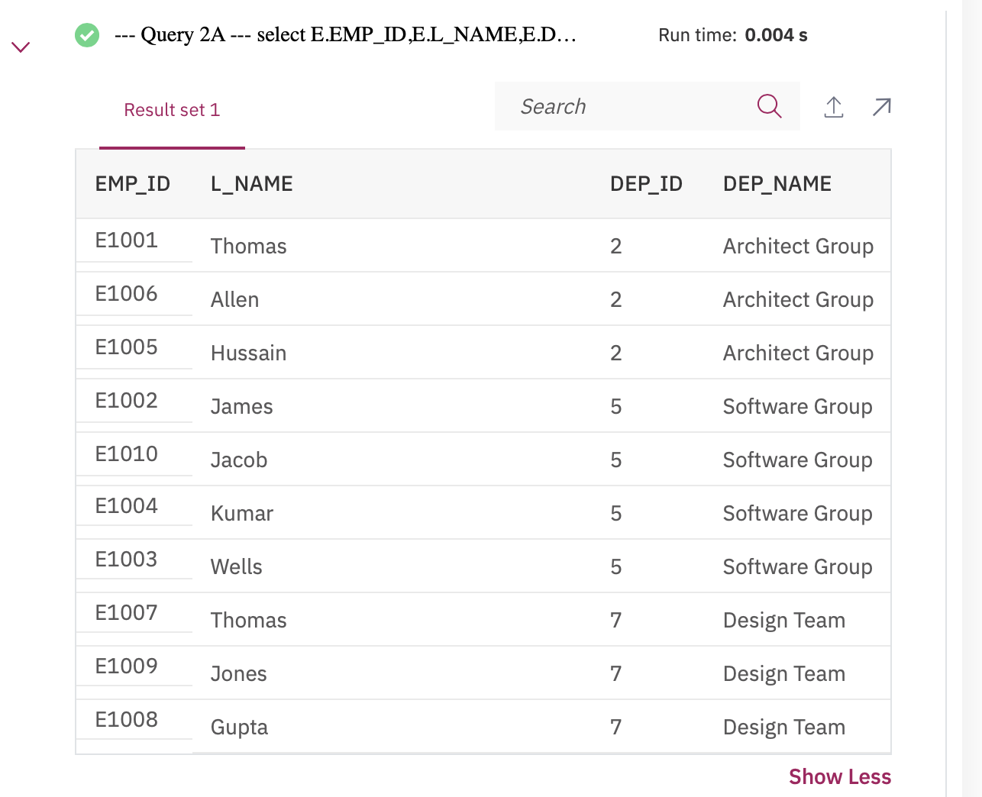

- Re-write the previous query but limit the result set to include only the rows for employees born before 1980.
Hint – Use a WHERE clause and Left Outer Join operation. Alternatively, you could also use an INNER JOIN.

Select E.EMP_ID,E.L_NAME,E.DEP_ID,D.DEP_NAME
from EMPLOYEES AS E
LEFT OUTER JOIN DEPARTMENTS AS D ON E.DEP_ID=D.DEPT_ID_DEP
where YEAR(E.B_DATE) < 1980;

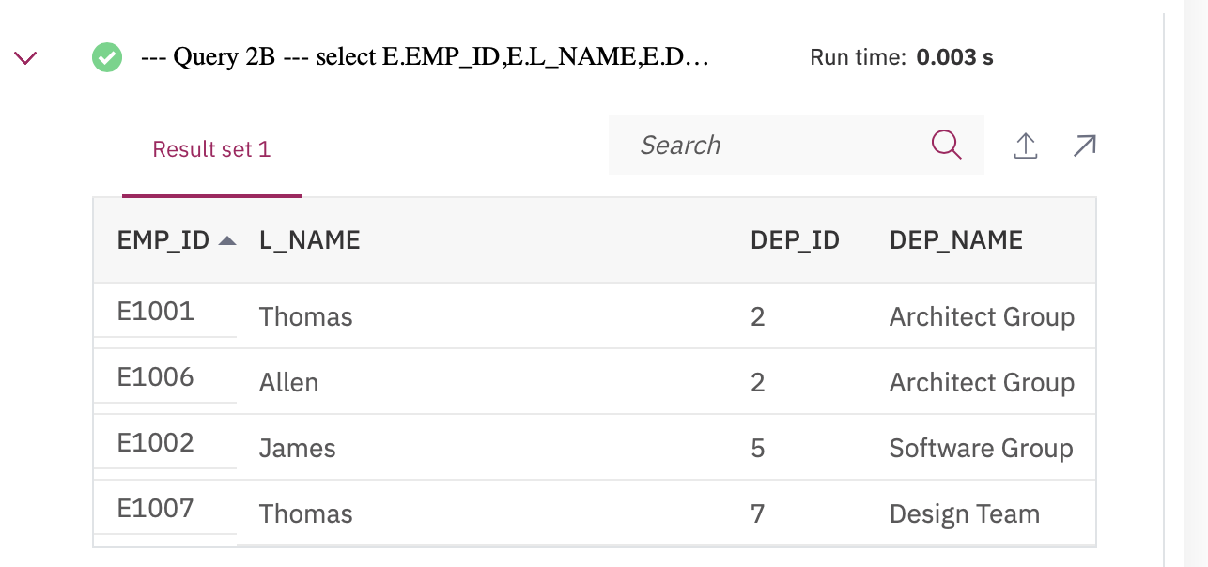
- Re-write the previous query but have the result set include all the employees but department names for only the employees who were born before 1980.
Hint- Use an AND in the LEFT OUTER JOIN clause.

select E.EMP_ID,E.L_NAME,E.DEP_ID,D.DEP_NAME
from EMPLOYEES AS E
LEFT OUTER JOIN DEPARTMENTS AS D ON E.DEP_ID=D.DEPT_ID_DEP
AND YEAR(E.B_DATE) < 1980;

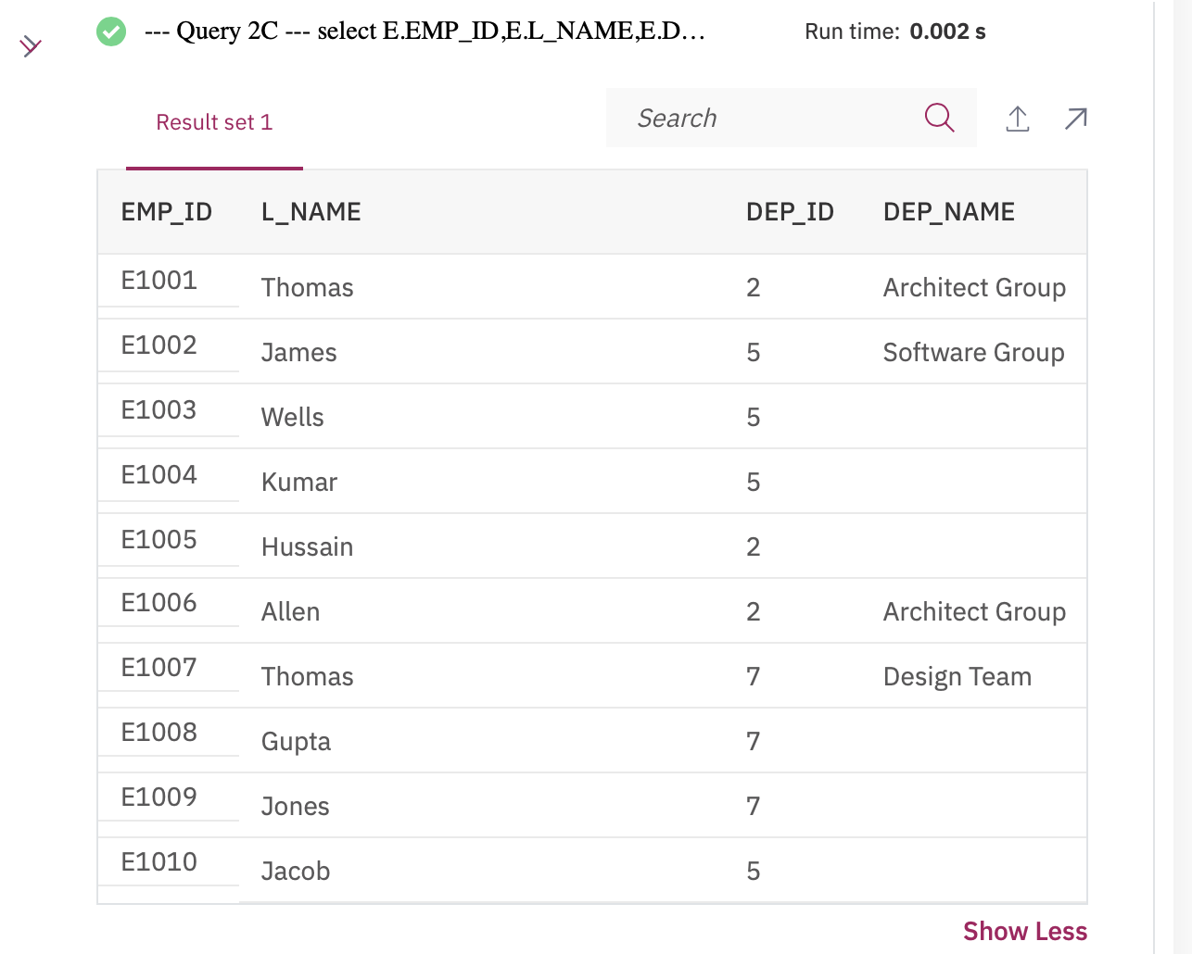
How does a RIGHT OUTER JOIN statement syntax look?
SELECT column_name(s)
FROM table1
RIGHT OUTER JOIN table2
ON table1.column_name = table2.column_name
WHERE condition;

How does a FULL OUTER JOIN statement syntax look?
SELECT column_name(s)
FROM table1
LEFT OUTER JOIN table2
ON table1.column_name = table2.column_name
WHERE condition

UNION

SELECT column_name(s)
FROM table1
RIGHT OUTER JOIN table2
ON table1.column_name = table2.column_name
WHERE condition

- Perform a Full Join on the EMPLOYEES and DEPARTMENT tables and select the First name, Last name and Department name of all employees.
Hint – Use the Full Outer Join operation with the EMPLOYEES table as the left table and the DEPARTMENTS table as the right table.
Select E.F_NAME,E.L_NAME,D.DEP_NAME
from EMPLOYEES AS E
LEFT OUTER JOIN DEPARTMENTS AS D ON E.DEP_ID=D.DEPT_ID_DEP

UNION

select E.F_NAME,E.L_NAME,D.DEP_NAME
from EMPLOYEES AS E
RIGHT OUTER JOIN DEPARTMENTS AS D ON E.DEP_ID=D.DEPT_ID_DEP
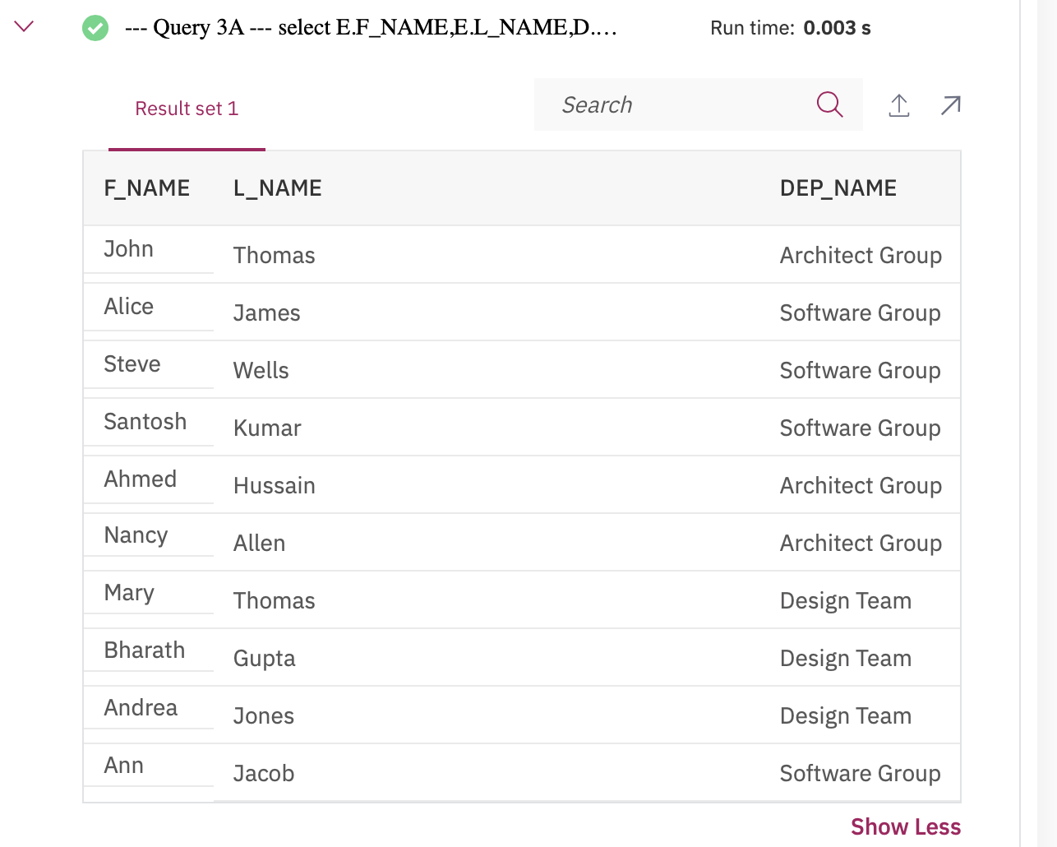

- Re-write the previous query but have the result set include all employee names but department id and department names only for male employees.
Hint- Add an AND in Query 3A to filter on male employees in the ON clause. Alternatively, you can also use Left Outer Join.
select E.F_NAME,E.L_NAME,D.DEPT_ID_DEP, D.DEP_NAME
from EMPLOYEES AS E
LEFT OUTER JOIN DEPARTMENTS AS D ON E.DEP_ID=D.DEPT_ID_DEP AND E.SEX = 'M'

UNION

select E.F_NAME,E.L_NAME,D.DEPT_ID_DEP, D.DEP_NAME
from EMPLOYEES AS E
RIGHT OUTER JOIN DEPARTMENTS AS D ON E.DEP_ID=D.DEPT_ID_DEP AND E.SEX = 'M';

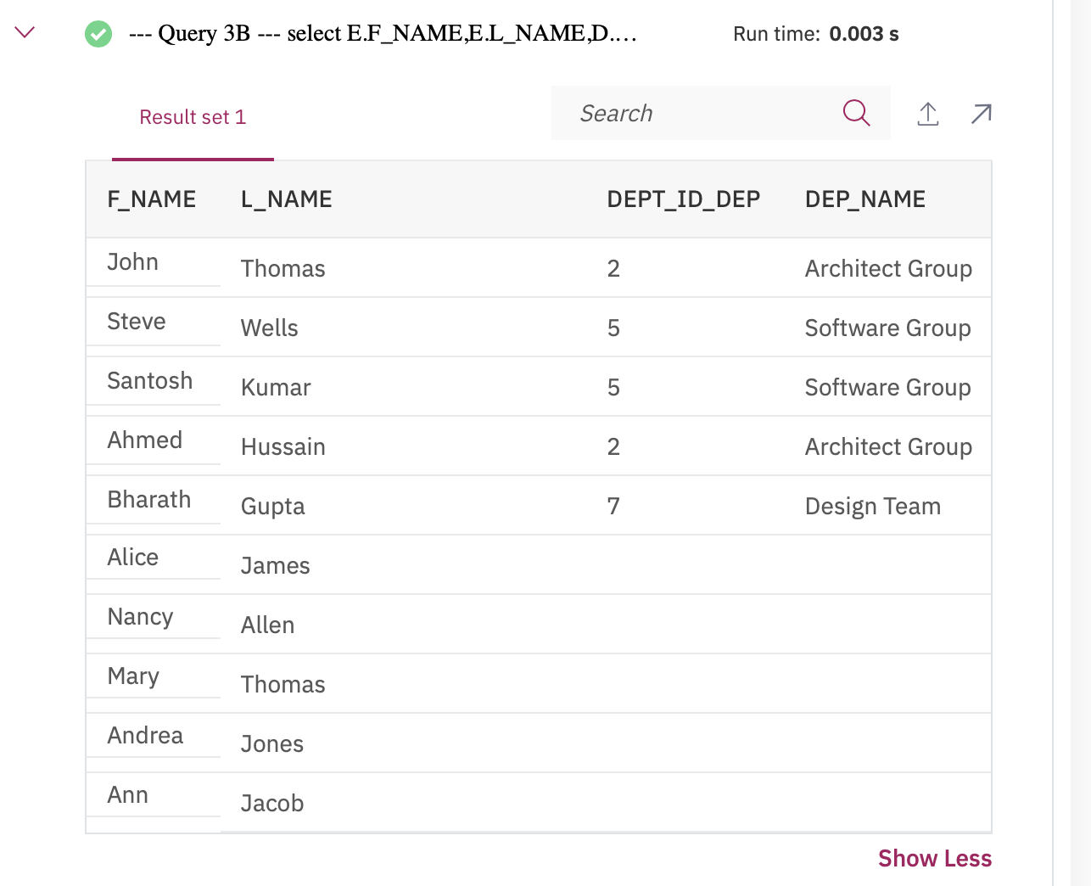
Union operator
The UNION operator is used to combine the result-set of two or more SELECT statements.
Every SELECT statement within UNION must have the same number of columns
The columns must also have similar data types
The columns in every SELECT statement must also be in the same order
SELECT column_name(s) FROM table1
UNION
SELECT column_name(s) FROM table2;

How does a SELF JOIN statement syntax look?
SELECT column_name(s)
FROM table1 T1, table1 T2
WHERE condition;

